Science Center Lesson Plan

Teacher candidate: Katherine Hunt Date: September 22, 2016
Provide the following information:
Name of Center: Introduction to Seasons
Date(s) of Implementation: Pre-assessment on September 20, 2016, activity on September 22, 2016
Standard(s) addressed in the center:
SKCS1. Students will be aware of the importance of curiosity, honesty, openness, and skepticism in science and will exhibit these traits in their own efforts to understand how the world works. a. Raise questions about the world around you and be willing to seek answers to some of the questions by making careful observations (5 senses) and trying things out.
SKCS4. Students will use the ideas of system, model, change, and scale in exploring scientific and technological matters. a. Use a model—such as a toy or a picture—to describe a feature of the primary thing.
SKCS5. Students will communicate scientific ideas and activities clearly. b. Begin to draw pictures that portray features of the thing being described.
SKE1. Students will describe time patterns (such as day to night and night to day) and objects (such as sun, moon, stars) in the day and night sky.
SSKH3 The student will correctly use words and phrases related to chronology and time to explain how things change.
ELAGSEKRF1: Demonstrate understanding of the organization and basic features of print.

Learning target(s):
Students will be able to sort cards with pictures based on the season they belong in.
Students will recognize concepts about print and be able to track their print in the poem.
Students will explore materials and learn to connect features to specific seasons.

Materials required:
- Poem worksheet
- Tree worksheet of blank trees to decorate
- 115 Fall color M&Ms (enough for 20 students)
- Pink Tissue paper already cut into little square pieces (enough for 20 students)
- Green construction paper pieces already torn apart (enough for 20 students)
- 25 cotton balls that will be torn apart for the students to glue down
- Glue sticks
- Poster board for visual representation and instructions
- Velcro to attach cards to poster board
- Cards with visual pictures to sort from each season

Modifications made to ensure successful participation for all students. Consider varied levels of readiness, and students with special needs:
- Groups are based on differentiated instruction
- Some students will need more hands on guidance with the craft than others
- In lower groups read the poem all together instead of individually. Read the poem multiple times for each group before letting them do it individually.

Narrative description of the three tasks:
I will have my poster board on display and have all supplies laid out for students when they come to the center with the exception of the supplies going on the trees. They will need a pencil to track their print and write their name, the copy of the poem, the paper with the undecorated trees, and a glue stick. I will open the activity with my introduction and discuss with the students first what they know about seasons and how weather changes. The students will be able to talk with the others in the group about what they know. My poster board will already be decorated with the trees to show what they will be doing and also to provide different sections for the students to sort the cards. The decorated trees on my poster will each have a strip of Velcro under each season for students to place the cards after determining where they go. The cards are shuffled and students will chose one at the time to place on the poster board. For example the hot chocolate card would be placed under winter. I may ask students how they feel in winter and why they may want to drink hot chocolate. Students can have multiple turns depending on group size. The poem will also be presented on the poster. We will read the poem together with me tracking the print on the poster and then letting them individually track their print as we all say it together. Lastly we will make our craft. I will hold up each material separately and let them decide what tree it belongs to. An example of this would be holding up pink tissue paper to go on the spring tree. The students will each glue down their supplies as I pass them out. This will be working on their fine motor skills. I will tell the students to not eat the M&Ms when I pass them out and that if they are good I have some for eating at the end. I will close the activity by passing out fall colored M&Ms to eat and talk with the students about the first day of fall and what they expect will happen in this time of year based on what we have talked about. We will clean up and I will repeat the activity two more times.

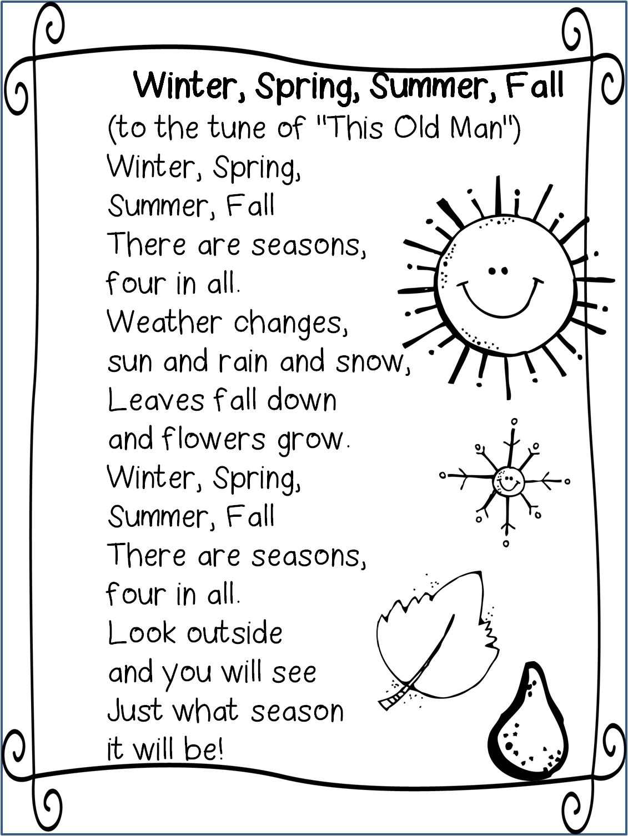
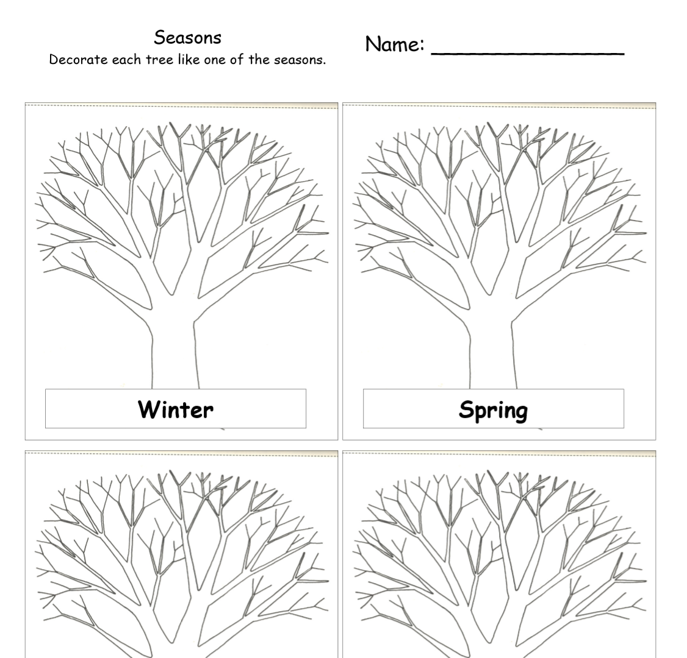
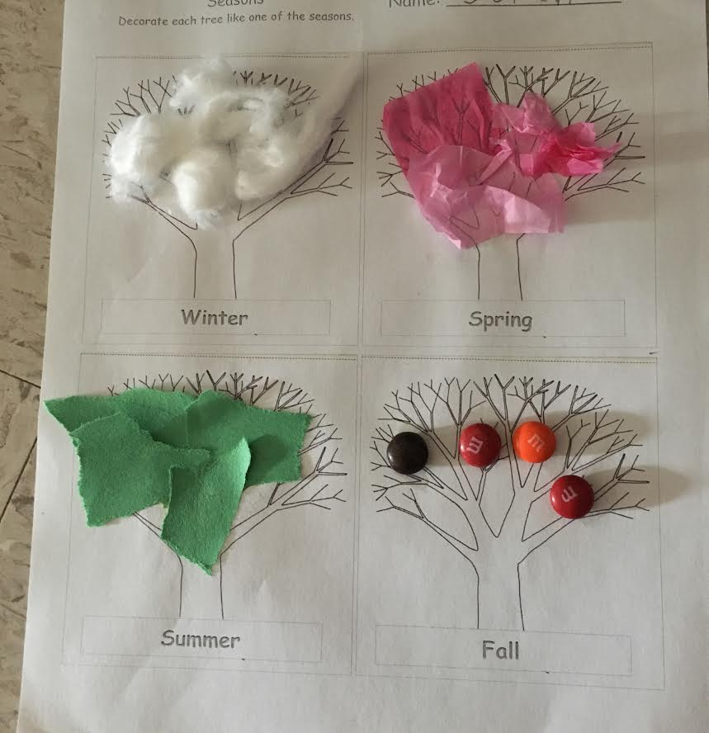
Example of Student Work

